## Installation Guide

## Setting up environment at server site

The following software must be installed into the server machine:

#### Hardware requirements

VPS server to run the web and service

* CPU 1 Core 2.0GHz.
* 512MB of RAM.
* 20GB of hard disk.

A personal computer to access VPS server:

* CPU Core i3 2.27 GHz
* 2GB of Ram
* 50GB of hard disk

#### Software requirements

Software to run in VPS server:

* Java environment: Java 1.7.0_51
* Web Server: Tomcat 7.0
* Operation system: Linux 13.10
* Database management: Mysql 5.5.20
* Other library:
* OpenCV 2.4.8
* JsonCpp 0.5.0

Software to run in personal computer to process the deployment:

* SSH Client to access VPS server
* FTP Client to upload file to VPS server

In this guide we can use Firefox with FireSSH and FireFTP addon.

#### Mobile Requirement

* Android 4.0
* Camera 5.0 Megapixel

## Deployment at server side

#### Prepare deployment package

* From personal computer access to VPS using FireFTP and FireSSH
* Upload deployment package to a folder on server, for example /home/deploy/deployment.zip
* Extract the deployment.zip
* Run the install.sh script to install the requirement software and library (this may take about 1h or more depend on your VPS internet connection). Flow the guide of script to complete the installation.
* Reboot VPS



**Figure 73: Prepare deployment package**

#### Deploy database

* Using SSH client, extract DB.sql script by command: mysql –u root –p
* Enter your mysql root password
* Then extract database by command: source DB.sql;

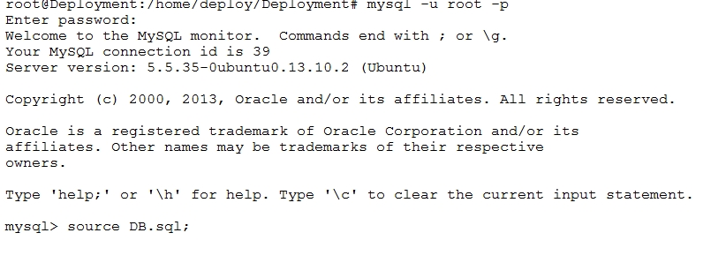

**Figure 74: Deploy database**

#### Deploy web application on server

* Run tomcat server by script: startup.sh



**Figure 75: Run tomcat server**

* Copy 2 War file TrafficService.war, TrafficWeb.war to webapps folder of tomcat and wait to tomcat auto deploy the war file.



**Figure 76: Copy war file to tomcat server**

* Edit the console app path in config.properties file this case: /home/deploy/Deployment/TSRT/



**Figure 77: Set console application path**

* Edit the web service address in the config.properties of TrafficWeb: http://yourwebaddress/TrafficService/



**Figure 78: Set Web service address**



**Figure 79: Restart tomcat**

## Setting up the environment at client side

#### Setting up for computer

* The client devices need to have one of the following browsers to access the website:
* Google Chrome 34.
* Firefox 27.

#### Setting up for Android devices

* Change setting to install unknown source apk.

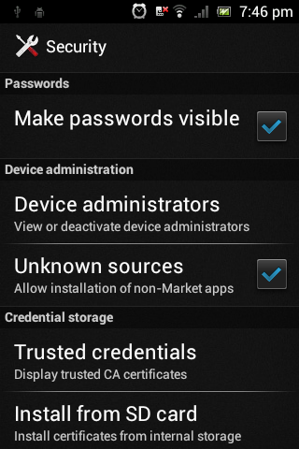

**Figure 80: Change Settings**

* Copy file TrafficSignRecognition.apk into mobile device.
* Use mobile device to open file above.
* Click Install to install the app.

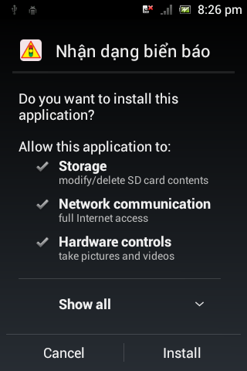 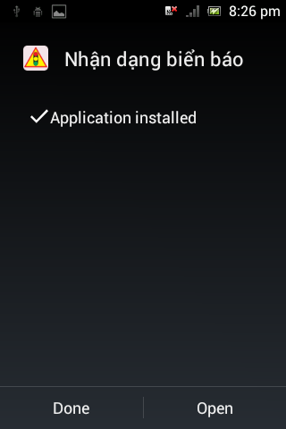

**Figure 81: Install App**